1 Corinthians 1:10 (NASU)

Now I exhort you, brethren, by the name of our Lord Jesus Christ, that you all agree and that there be no divisions among you, but that you be made complete in the same mind and in the same judgment.

1 Corinthians 1:10 (NKJV)

Now I plead with you, brethren, by the name of our Lord Jesus Christ, that you all speak the same thing, and that there be no divisions among you, but that you be perfectly joined together in the same mind and in the same judgment.

1 Corinthians 1:10 (CWSNT)

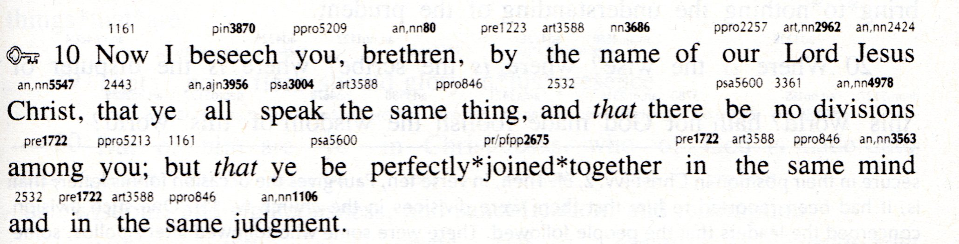
__________________________

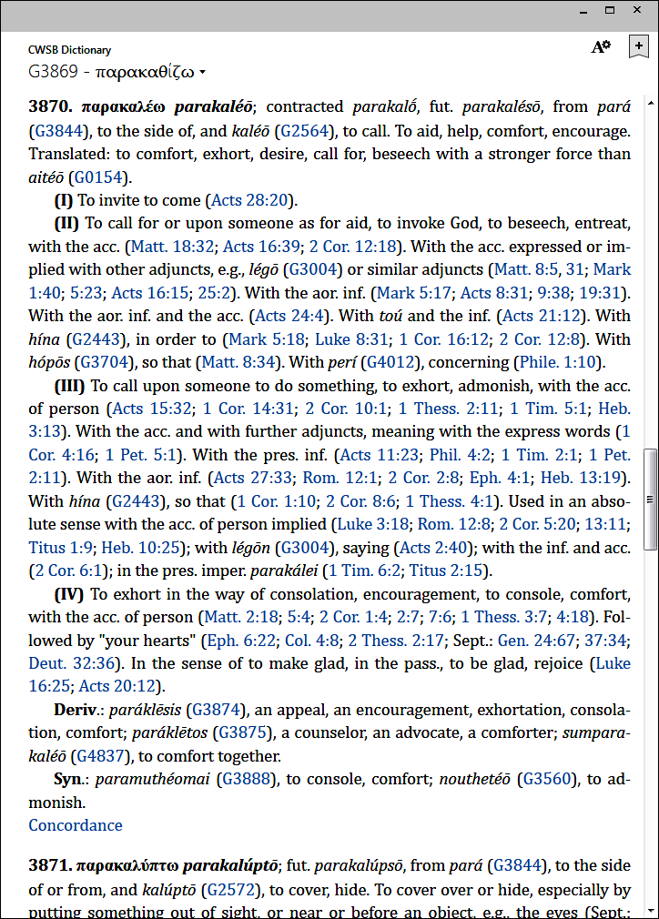

See also the Supplement for today, "Biblical Counseling Words" regarding the Greek word with the Strong's number 3870 (parakaléō).
Strong's number 2675:


